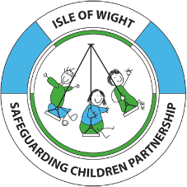
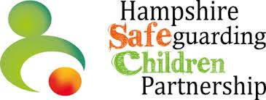
Day in my Life: Unborn Baby

Questions | Responses | Notes
Emotional connection with baby
- Do my parent(s) talk to me?
- Are my parents excited to meet me?
- Do I have a name?
- Was I planned?
- Do I have a father who will help to care for me?

Diet/Lifestyle
- Does my mother have a healthy diet?
- Is my mother following the midwife’s advice about eating and drinking? Is my parent supported with this?
- Am I exposed to alcohol or substances including tobacco?
- Is my mother/are my parents working to reduce my exposure to substances/alcohol/tobacco?
- Is my mother doing gentle exercises like walking and getting outside?
Appointments

- Do I get seen regularly by midwives?
- Am I seen at planned scans?
- Do I go to all appointments made for me?
Relationships/Extended family

- Is there extended family that are excited to meet me?
- Do I have family that will help my parents prepare for me?
- Do I have siblings? Will they live with me? Are they excited to meet me?
- Did my parents have good examples of how to care for me?
- Are my parents going to care for me together?
- Do my parents live together?
- Do my parents like each other?
- Are my parents in a new relationship?
- Do my parents have friends that they meet regularly? What are these friends like?
- Do my parents’ friends have children?

Prep for baby
- Can my parents afford to buy me all that I need?
- Will I have a safe place to sleep?
- Have my parents learnt how to care for me?
- Have my parents been learning what I will need to be safe?
- Do my parents know about Every Sleep Counts and ICON

Home conditions

- Am I exposed to second-hand smoke at home?
- Does my mother feel safe at home?
- Does my mother have somewhere to sleep that is secure?
- Would I be safe in the current home conditions?
Mental Health

- Am I exposed to high levels of stress hormones?
- Does my mother worry a lot about me?
- Does thinking about me make my mum feel better or worse?
- Am I exposed to medications?
- Do any adults living with my mum suffer with mental health problems?

Finances

- Can my parents afford to buy all that I need to be safe?
- Will my parents be able to buy for my needs e.g nappies, formula milk if used?
- Does thinking about money make my parent(s) anxious?
- Will I have a secure home to live in?
Wider Community Support
- Is there anyone else supporting my parents to prepare for me?
- Do my parents know how and where to get help if they need it?
- Do I have a social worker?
Additional considerations
- Do my parents feel safe? Is there a high level of conflict in the home? Is there risk of domestic abuse?
- Does my mum have a history of post-natal depression?
- Do my parents have a history of misusing substances such as alcohol and drugs?
- Have either of my parents been involved in the criminal justice system?
- Have my parents had previous children taken into the care system?
- Have my parents had a baby who died?
- Do my parents have a learning difficulty, complex health needs or a disability. Will this affect how they will be able to care for me?
- Did my parents/carers have involvement with children’s services when they were a child?
- Is my parent a recent care leaver?
- Have my family from another country because it was unsafe to live there? Do we have support from other services that are aware?
- Has the HIPS Unborn Baby Protocol been considered as needed?

