This resource can be used to explore a day in the life of a child and their views. This gives an understanding of a child’s daily lived experience – how their world looks and feels to them. Please consider how their identity and culture may also impact on their life.

Understanding a child’s life can be achieved through discussion with the child, parent/carer, other family members, play, observation and 1-1 work with the child. This provides an opportunity to get to know the child better and support relationship building.

Prompt questions are included overleaf. Please note this is not a list of questions to ask every child but a series of prompts to consider different times during the day and the child’s views of this. It is not an exhaustive list and can be used flexibly to suit individual children depending on their age and/or development.

Please use additional resources as needed to support your work with a child.

This document may be used in conjunction with the HIPS Child Exploitation Risk Assessment Form (CERAF). If you have concerns about potential neglect of a child, please refer to the comprehensive Day in the Life tools provided in the Neglect Toolkit.

For any concerns about a child, please consult the Hampshire and Isle of Wight Threshold Chart and where necessary, complete the Inter-Agency Referral Form (IARF) for all social care referrals, information shares/requests and updates.

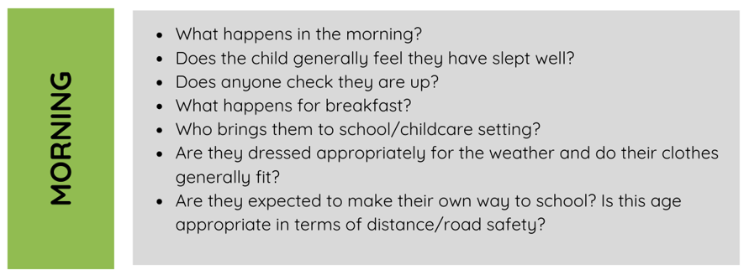
PRACTITIONER NOTES

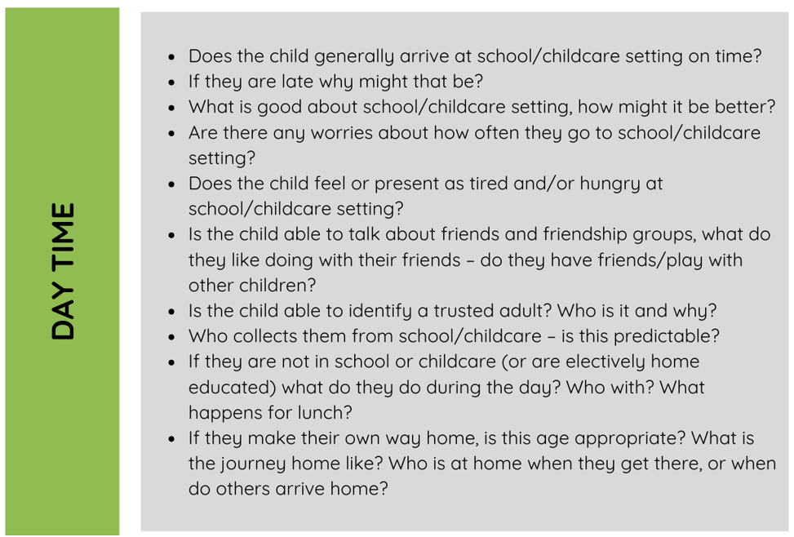
PRACTITIONER NOTES

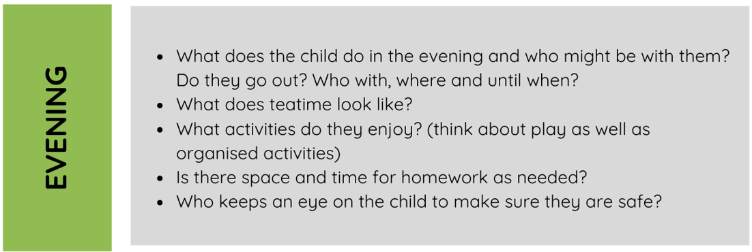
PRACTITIONER NOTES

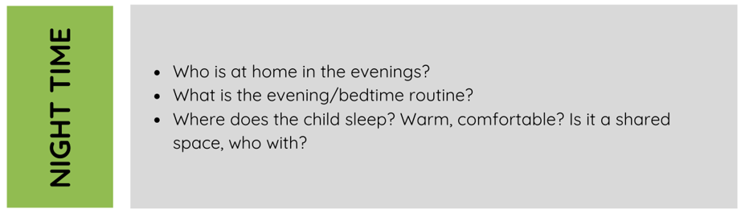
PRACTITIONER NOTES

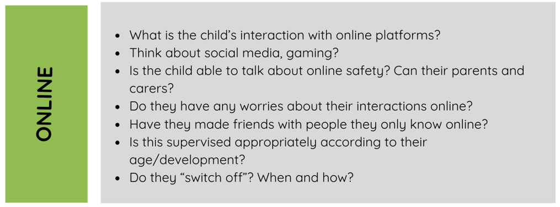
PRACTITIONER NOTES

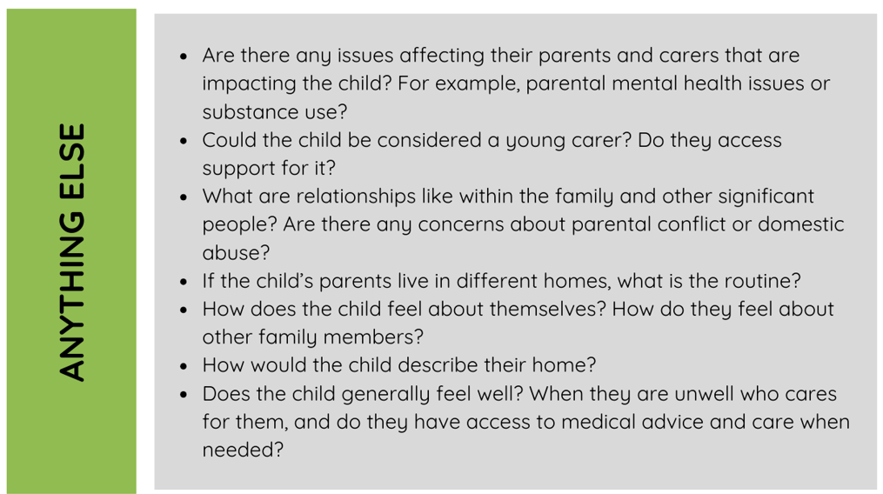
PRACTITIONER NOTES

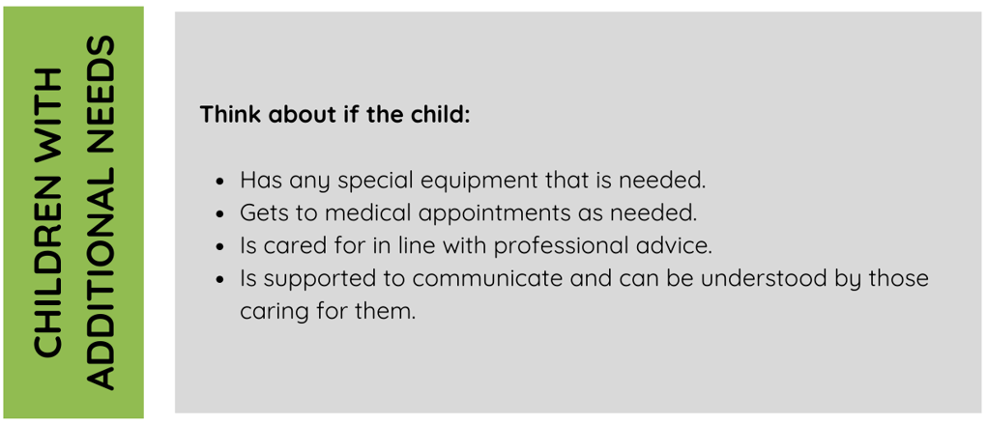
PRACTITIONER NOTES

