SOCIAL MEDIA PLAN
for Partners

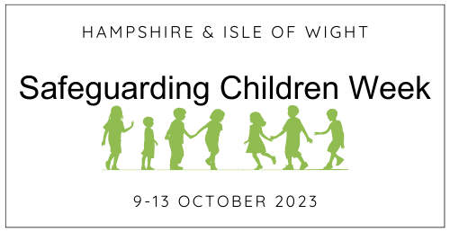

Background

The first ever Hampshire and Isle of Wight Safeguarding Children Week will be held next week, running from 9 to 13 October 2023.
Safeguarding Children Week has been developed by the Hampshire and Isle of Wight Safeguarding Children Partnerships as an annual opportunity to bring together agencies and organisations across Hampshire and the Isle of Wight to raise awareness among partners, professionals and community and voluntary leaders about the importance of safeguarding children and promoting their welfare.
All organisations that work with children and young people, whether in a voluntary or paid capacity, have a responsibility to protect children from harm. The aim for the week is to enable anyone working with children and families to feel confident in helping and supporting those children who need it most.
Each day of Safeguarding Children Week will promote a different theme, that will be ‘unlocked’ each morning for practitioners to access via the Safeguarding Children Week website.
The Week will include the release of several new toolkits, messages from senior managers and key learning that can be applied to practice. Practitioners are encouraged to visit the website every day to learn more. Please see the full programme schedule for further information.

X/Twitter

Children’s Safeguarding Week will be promoted ahead of, and during, the week of 9 October.

HSCP @HampshireSCP and IOWSCP @IOWSCP will be posting on X/Twitter. Partners and individuals are encouraged to repost and promote Tweets/posts, always using the hashtag #safeguardingchildren2023. If you use other social media channels, such as Facebook, please adapt the resources where necessary.

Social media plan for partners

Please note, that the theme for each day will be unlocked each morning of Safeguarding Children Week. Please post messages/tweets after 10am to allow for each day to be ‘unlocked’.

Date | Post | Image
Prior to 9 Oct | We are proud to be supporting the first ever Hampshire and Isle of Wight Safeguarding Children Week to raise awareness on the importance of safeguarding children from harm and promoting their welfare. Find out more at https://www.hampshirescp.org.uk/safeguarding-childrens-week-2023/  #safeguardingchildren2023 | 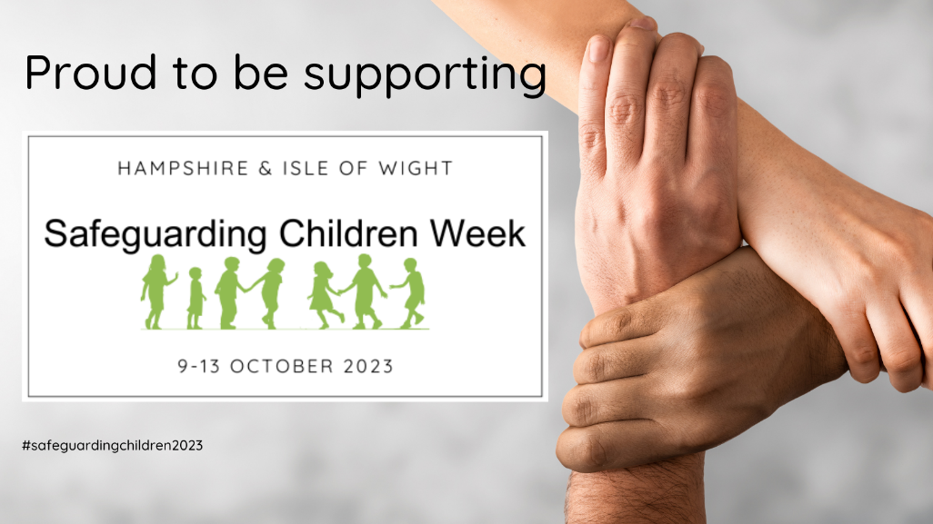
Mon, 9 Oct | This week is Hampshire & Isle of Wight Safeguarding Children Week & we’re coming together with our partners to raise awareness on the importance of safeguarding children & promoting their welfare. Find out more https://www.hampshirescp.org.uk/safeguarding-childrens-week-2023/  #safeguardingchildren2023 | 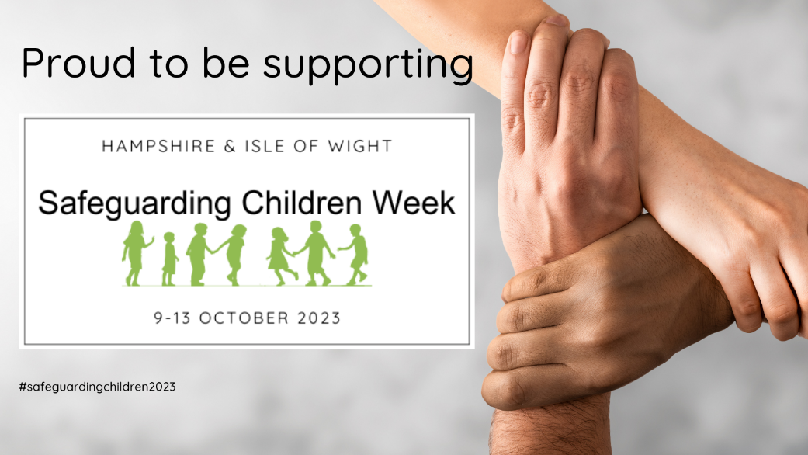
Mon, 9 Oct  Hants only | As part of Safeguarding Children Week @HSCP today launch a new Prevent Toolkit to support Hants professionals in safeguarding children from radicalisation & extremism. Go to https://www.hampshirescp.org.uk/safeguarding-childrens-week-2023/monday/  #safeguardingchildren2023 | 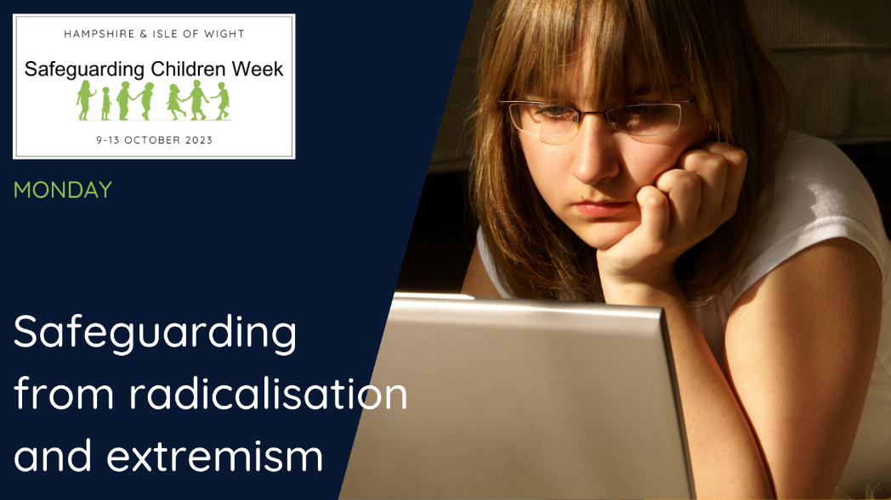
Mon, 9 Oct | Are you a community or voluntary organisation that works with children & young people? To support you in your safeguarding duties @HSCP & @IOWSCP have today launched a new toolkit. Go to https://www.hampshirescp.org.uk/safeguarding-childrens-week-2023/monday/  #safeguardingchildren2023 | 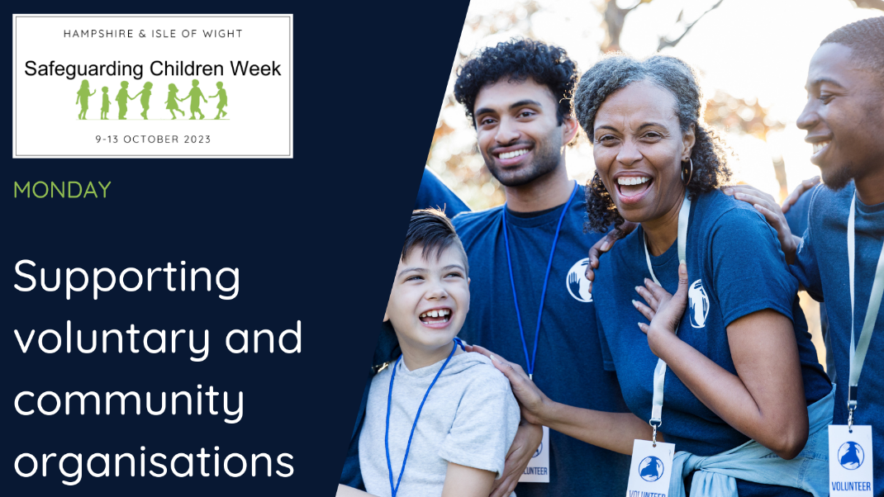
Tues, 10 Oct | Today, Hampshire, Isle of Wight, Portsmouth & Southampton (HIPS) Safeguarding Children Partnerships launch their Child Exploitation Toolkit for professionals. For more info and to book a free place go to https://www.hampshirescp.org.uk/safeguarding-childrens-week-2023/tuesday/  #safeguardingchildren2023 | 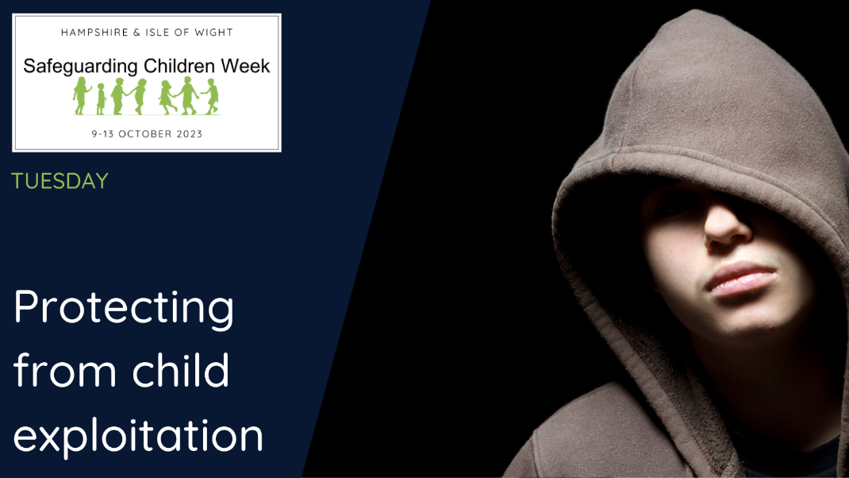
Wed, 11 Oct | Train together, learn together, safeguard together.  Explore the diverse multi-agency safeguarding training that @HSCP & @IOWSCP offer to professionals. Go to https://www.hampshirescp.org.uk/safeguarding-childrens-week-2023/wednesday/  #safeguardingchildren2023
Thurs, 12 Oct | Themes from safeguarding practice reviews regularly highlight the vulnerabilities of infants <1. To support professionals working with new/expectant parents @HSPC & @IOWSCP have launched a Toolkit on Safeguarding Infants. Go to https://www.hampshirescp.org.uk/safeguarding-childrens-week-2023/thursday/  #safeguardingchildren2023
Fri, 13 Oct | If you work with children & families, you can play a key role in advising families on the most common parenting challenges & signposting them for further help when needed. See the resources @HSCP & @IOWSCP have for parents/carers https://www.hampshirescp.org.uk/safeguarding-childrens-week-2023/friday/  #safeguardingchildren2023

Further information and support

If you require any further support on promoting Safeguarding Children Week or have any questions, please contact the HSCP or IOW SCP Partnership Team on the email below.

Please let us know what you have done to support Safeguarding Children Week so we can ensure to include you in the post evaluation report.

Email
Hampshire: HSCP@hants.gov.uk
IOW: scp@iow.gov.uk

